**STD - DOCUMENT**

Movie website

By: Aya motlk

3/7/2023

Contents

Introduction 3

Document overview 3

The tests will be executed during Validation testing: 3

user data: 3

project references: 3

Testing Objectives 3

Testing Strategy 4

Test Environment 4

Test Plan 4

Test Cases 5

Test Results 6

Conclusion 6

**STD- Software test description**

# Introduction

## Document overview

This document is the software test description it contains the description of tests list in software test plan.

The purpose of this STD document is to outline the testing approach and strategy for the "Movies Website(flask)" project. The project is being developed to provide a platform for customers to read description about the movie and witch short video about the movie that how choose. The website will be developed using a combination of python, flask, database, HTML, CSS and JavaScript programming languages.

## The tests will be executed during Validation testing:

– Integration testing

– System testing

## user data:

URL: <http://127.0.0.1:5000>

## project references:

|  |  |
| --- | --- |
| **Documents** | **Document title** |
| SRS | Software requirement specification |
| STP | Software test plan |

## Testing Objectives

The testing objectives for the movie Website project are:

* To ensure that the website is functional and user-friendly
* To ensure that the website meets all specified requirements.
* To identify and report any defects or issues found during testing.
* To complete testing within the specified timeline and budget.
* To ensure that the website is scalable and maintainable.

## Testing Strategy

The testing strategy for the Movie Website project is as follows:

A combination of manual and automated testing will be used

Testing will be performed in multiple phases (unit testing, integration testing, system testing, and acceptance testing)

Black-box and white-box testing techniques will be used

Testing will be performed by a dedicated testing team.

## Test Environment

The test environment for the Movie Website project is as follows:

Operating System: Windows 10

Web Browsers: Google Chrome, Mozilla Firefox, Microsoft Edge

Web Server: Flask

Database: SQLITE

Test Data: A combination of real and simulated data will be used.

## Test Plan

The test plan for the Movie Website project is as follows:

Unit Testing: Testing of individual components/modules of the website will be performed by developers

Integration Testing: Testing of the integration between different modules of the website will be performed by developers and testers

System Testing: End-to-end testing of the entire website will be performed by testers

Acceptance Testing: Testing of the website from the customer's perspective will be performed by testers and stakeholders

Each testing phase will be performed according to the specified schedule and resources.

## Test Cases

The test cases for the Movies Website project are as follows:

Functional Test Cases: Test cases that cover all functional requirements of the website will be developed and executed

Non-Functional Test Cases: Test cases that cover non-functional requirements such as usability, performance, and security will be developed and executed

Test cases will be designed to cover all possible scenarios and edge cases.

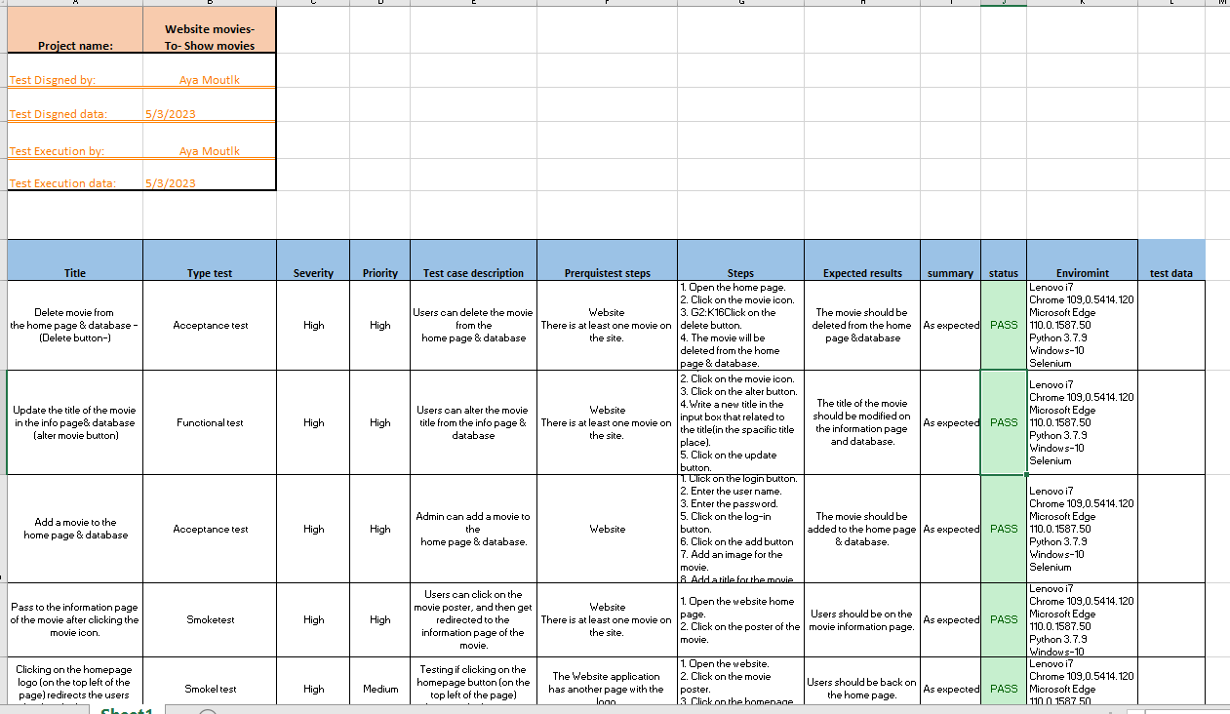

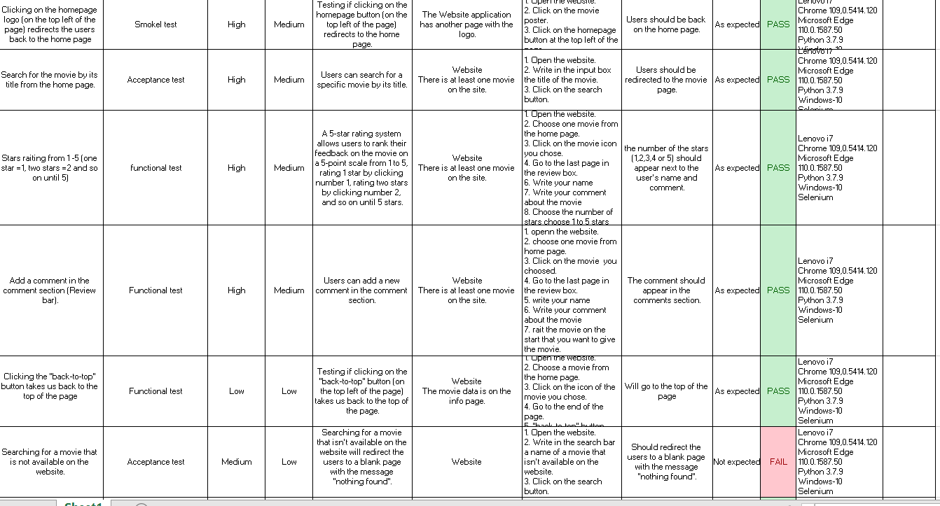

## Test Results

The test results for the Movies Website project will be documented as follows:

Defects and issues found during testing will be recorded in a defect tracking tool

The severity of each defect and issue will be assigned

The steps to reproduce each defect and issue will be documented

The status of each defect and issue (open, resolved, closed) will be updated as necessary

# Conclusion

In conclusion, the testing approach and strategy outlined in this STD document will ensure that the Movies Website project meets all specified requirements and is functional, user-friendly, and scalable. All stakeholders have reviewed and approved this STD document, and testing will begin according to the specified schedule and resources.